1. Write a leave management system to an organization to apply for leaves such as CL, ML and store them in the MongoDB.
2. Write a leave management system to an organization to view for leaves such as CL, ML and their availability details from the MongoDB.

**Front-end:**

**App.js**

import logo from './logo.svg';

import './App.css';

import { Route, BrowserRouter as Router, Routes } from 'react-router-dom';

import Leave_apply from './Leave_apply';

import Leaves_view from './Leaves_view';

function App() {

  return (

    <div className="App">

      <Router>

        <Routes>

          <Route path = '/' element = {<Leave_apply />}/>

          <Route path = '/view' element = {<Leaves_view />}/>

        </Routes>

      </Router>

    </div>

  );

}

export default App;

**Leave_apply.jsx**

import React, { useState } from 'react';

import axios from 'axios';

function Leave_apply(){

    const [type, setType] = useState('');

    const [name, setName] = useState('');

    const [result, setResult] = useState('');

    const handleClick = async ()=>{

        const res = await axios.post('http://localhost:5000/', {type, name});

        setResult(res.data);

    }

    return(

        <div>

            <h1> Apply leave </h1>

            <input type="text" placeholder = "CL or EL" onChange={(e)=>setType(e.target.value)}/>

            <input type = "text" placeholder = "name"    onChange={(e)=>setName(e.target.value)}/>

            <button onClick={handleClick}> Click me </button>

            {result}

        </div>

    );

}

export default Leave_apply;

            <button onClick={handleClick}>click me </button>

            <h2 id='id1'></h2>

        </div>

    );

}

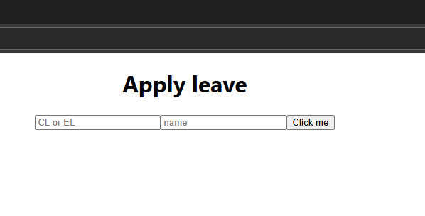

**Leaves_view.jsx**

import React, { useState } from 'react';

import axios from 'axios';

function Leaves_view(){

    const [name, setName] = useState('');

    const [result, setResult] = useState('');

    const handleSubmit = async ()=>{

        const res = await axios.post('http://localhost:5000/view', {name});

        setResult(res.data);

    }

    return(

        <div>

            <h1> View the leaves </h1>

            <input type='text' placeholder = 'person"s name' onChange={(e)=>setName(e.target.value)}/>

            <button onClick={handleSubmit}> Submit it </button>

            {JSON.stringify(result)}

        </div>

    );

}

export default Leaves_view;

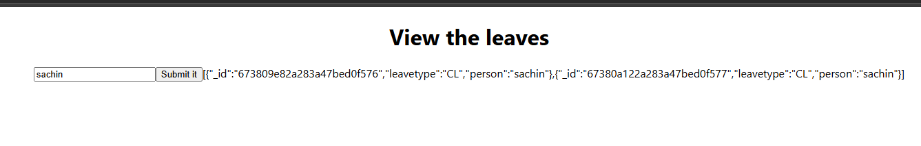

**Back-end:**

const express = require('express');

const app = express();

const cors = require('cors');

app.use(cors());

const bodyParser = require('body-parser');

app.use(bodyParser.json());

app.use(express.urlencoded({extended: true}));

app.listen(5000, ()=>{

    console.log('The server is waiting ...');

});

const {MongoClient} = require('mongodb');

const client = new MongoClient('mongodb://localhost:27017');

app.post('/', async (req, res)=>{

    const result = await client.db('leavemgmtdb').collection('col1').insertOne({'leavetype': req.body.type, 'person': req.body.name});

    if (result.acknowledged == true){

        res.send('success');

    }

    else{

        res.send('Fail');

    }

    res.end();

});

app.post('/view', async (req,res)=>{

    const result = await client.db('leavemgmtdb').collection('col1').find({'person': req.body.name}).toArray();

    if(result != 0){

        console.log(result);

        res.json(result);

    }

    else{

        console.log(result);

        res.send('Fail');

    }

    res.end();

});